1. **Agenda**:
   1. Ideal architecture to be followed to resolve the challenges faced for configuration management.
2. 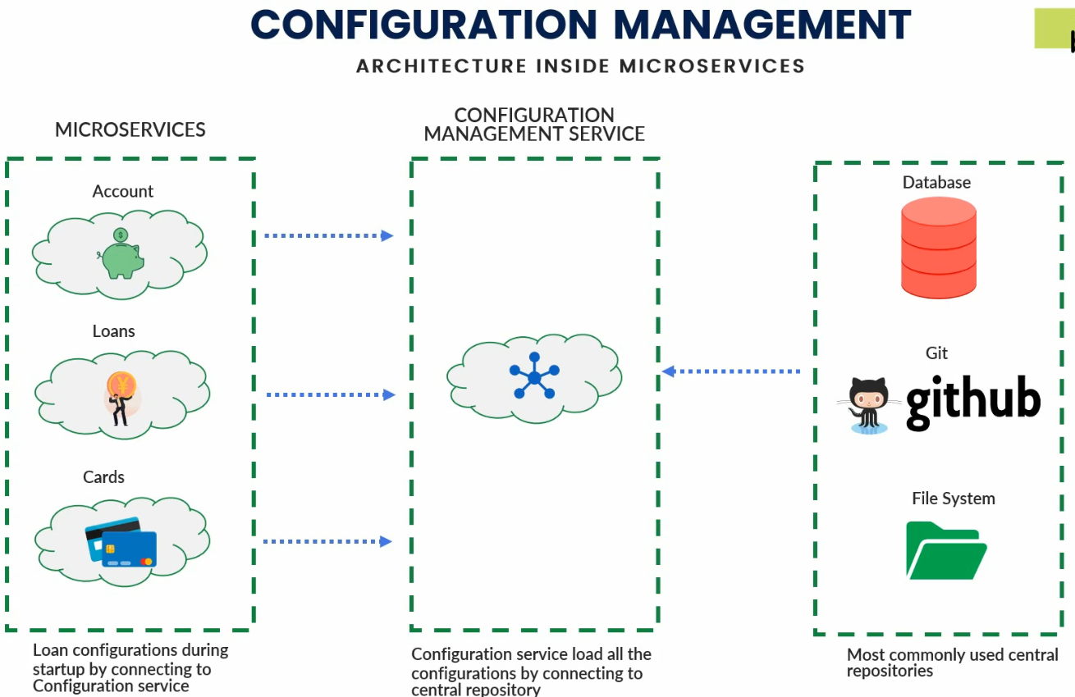
3. Actually, we create a configuration management service in an isolated way similar to we create microservices around the business entities.
4. So Configuration Management Microservice loads all the configurations for all Microservices and for all environments.
   1. **For example**:
      1. Suppose we have 3 microservices 🡺 Accounts, Loans, Cards 🡺 Total 3
      2. Suppose we have 3 environments 🡺 Development, Test, Production 🡺 Total 3
      3. Now, configuration management microservice will maintain 9 different kinds of configurations.
5. Many Options where we can store configurations:
   1. **Github**: Most commonly used central repository to store configurations is **Github**.
   2. **File System**: On your local computer’s file system or in local network.
   3. **Cloud Storage:** 
      1. **Amazon S3 Bucket**
      2. Or some other cloud storage.
6. We will also see how to make any change to configuration effective in configuration management microservice and business microservices without restarting them.
7. In next lecture, let’s see how Spring Cloud can help us to achieve this architecture through a sub project 🡺 **Spring Cloud Config**.